**PLEASE MOVE FIXED ISSUES TO FIXED BELOW**

Issues/Questions

1. Welcome, ! is not updated with the logged-in user.
2. What is the username? And where can we see it?

* Username - branchname separated by ‘_’ (underscore), in view user

example : tomasmorato

* Password - in view user

1. Are users supposed to unique? And what should be unique about them

username

QA stuff

* Test for lengths of entries for every entry?
* Add more entries for edit user

FIXED:

1. Functionality QA testing
   1. Back button
   2. Home
   3. Edit
   4. Delete
2. Center type of user in the registration form
3. After register, and view, pressing the back button returns to register
4. Co-admin registration has branch name
5. Commissary registration has branch name
6. For commissary and franchisee nakasulat co-admin
7. Successful account creation kahit nakablank lahat except last name
8. Back buttons in view a user should go back to list of users
9. Phone numbers when using arrow up down will remove 0 at the front
10. Postal code exceeded 4 digits
11. Phone number can be edited to infinite number in edit user
12. Pop ups should block other buttons and be prioritized as to limit the user being able to press other buttons such as delete and cancel can be pressed simultaneously and then press home (pa check nlng ung sa register if ok ung ganun - ivan)
13. Register cancel does not have a pop for if you want to leave page
14. Edit user button does not show pop up to confirm yes or no
15. Buttons in Pop-ups - only letters are clickable not whole button
16. 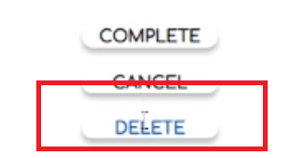
17. User information design error (see the city and postal code textboxes)
    1. 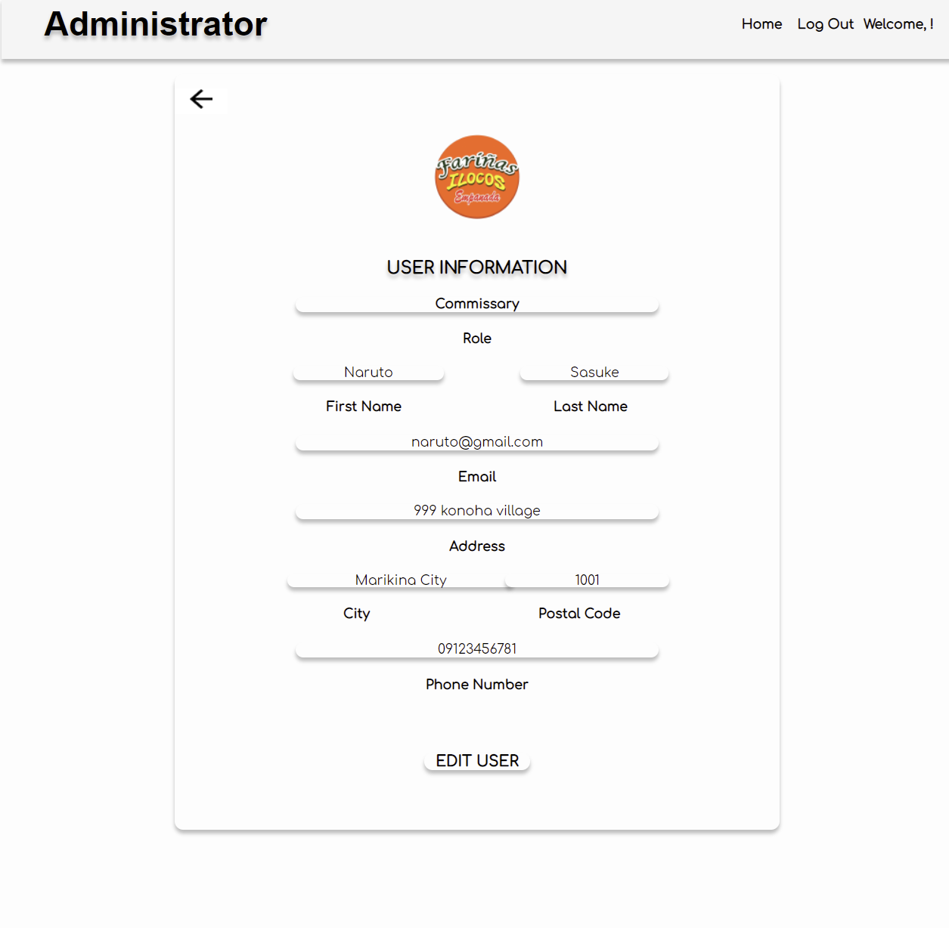
18. There is no entry to edit the branch for a franchisee
19. Phone number can be letters in register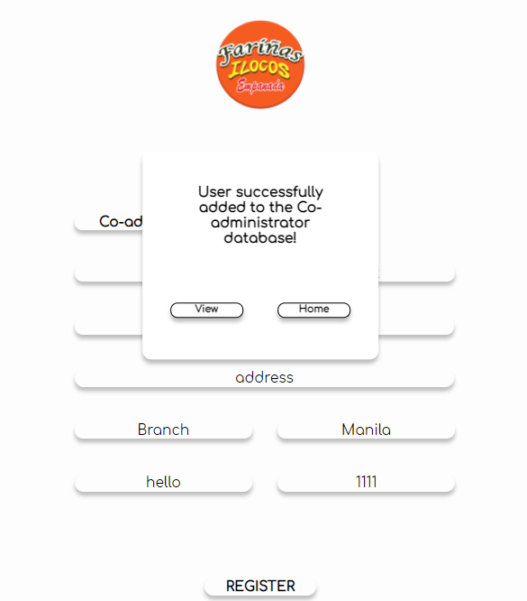q
20. Trim strings to remove spaces at the front and end